Mastercam India recently conducted a webinar on Efficient Manufacturing for Toolmakers, in association with TAGMA India.

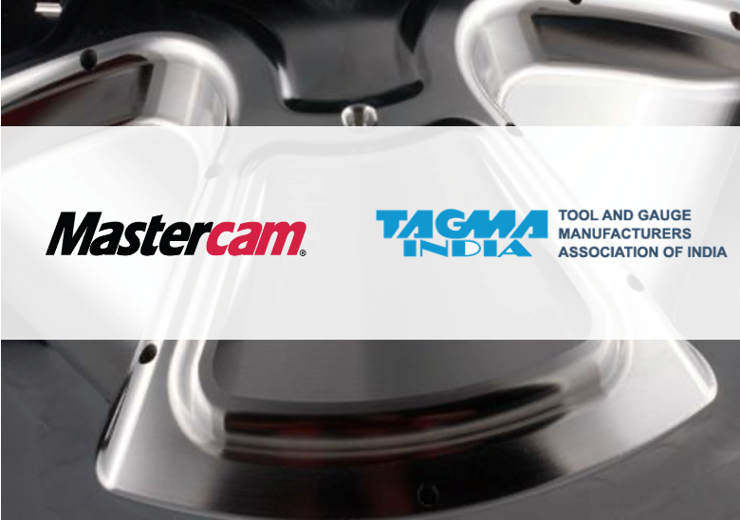
The webinar was promoted by TAGMA as part of the ‘TAGMA Digital Initiatives’, and saw an attendance of nearly 200 delegates from Die and Mould
companies from across the country.

Mr. Sitansu Mohanty, Technical Director at Mastercam APAC presented innovative strategies on efficient machining and techniques like Dynamic Motion technology and automatic 3+2 toolpath generation, amongst many other features that help Toolmakers optimise their machining processes.

Mr. Umakant Deshmukh, Director – Bespoke Projects and PP customisation, spoke on the science behind chip generation. He explained the differences between traditional and new-age High speed machining with the implications and benefits of using Radial Chip Thinning techniques to increase material removal rates.

The hour long presentation was followed by a rich Question and Answer session, with many Toolmakers asking some very interesting questions, with equally fascinating answers by the presenters, in response to the queries.

The webinar ended with a vote of thanks to the delegates who attended the event, and to TAGMA India for promoting the event within the fraternity.

Recorded session of this webinar is available upon request; please email marketing@mastercamapac.com with your complete name, mobile number & address,
and the team from Mastercam will reach out to you with the link.

