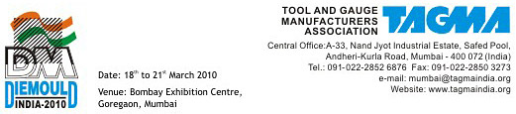

SUB: INVITATION TO PARTICIPATE IN THE 7TH DIEMOULD INDIA 2010 :
THE LARGEST INTERNATIONAL DIEMOULD EXHIBITION IN INDIA

Dear Sir,

Tool and Gauge Manufacturers Association (TAGMA) is organizing DIEMOULD INDIA 2010, the 7th Biennial Die & Mould International Exhibition from 18th to 21st March 2010 now again in Mumbai, Bombay Exhibition Centre (BEC), NSE Complex, Western Express Highway, Goregaon, Mumbai 400 063.

The 6th Die & Mould Exhibition held from 15th to 18th February 2008 at Bangalore International Exhibition Centre (BIEC), Bangalore was highly successful in terms of growth 110% in exhibition area, 35% in professionals/ business visitors and 400% increased area in international participation, highlight being three Country Pavilions from China, Germany and Singapore, the event also attracted exhibitors and delegations from over 25 Countries all over the world.

The regular participation of leading brands from India and abroad showcased their latest proven technologies, having features to improve productivity, quality and reduce costs , had attracted quality visitors to the exhibition.They expressed satisfaction seeing new innovative products, manufacturing process, covering the entire supply chain to the tooling industry, a wide spectrum to choose from in meeting faster deliveries required by the highly competitive manufacturing sectors.

The series of DIEMOULD exhibitions organized by TAGMA since 1998 has build growing global awareness and reputation as the largest trade fair in India for the Die & Mould Industry with international standards.

The 7th die mould India exhibition would provide all businesses related to the tooling industry an ideal and prestigious opportunity to display and market their products and services in a centrally air conditioned halls, with all supportive infrastructure, in the proximity of Mumbai Airport & having the best worldwide connectivity by air, road, rail and sea.

TAGMA cordially invites you to participate in DMI 2010 as an exhibitor and avail of the excellent marketing opportunity to grow your business, and wish you grand success in DMI 2010.

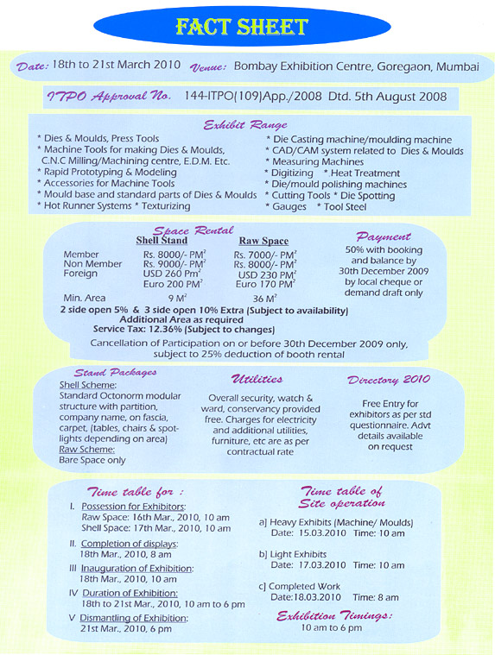

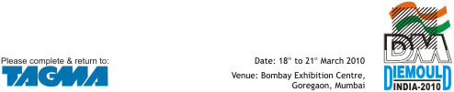

Free Directory Entry

Please complete in block capital letters correctly typed

Company Name *

Address:

Phone No: * Fax No :

E-mail: *

Exhibits Details (Not more than 100 words): *

Please indicate under which letter of the alphabet your company is to be listed.

Signature Name Designation

Space Application Contract

Top of Form
* Required Fields
Company * |  | Designation
Name * |  | Booking Date
Address *
  Fax
  Email *
City |  | Phone *
Pin / Zip |  | Mobile
State |  | Website
Country |  | Contact Person

Participation Charges [Please Tick (√) wherever applicable] | Amount
1. Space charges * (Raw space : minimum 36 sqm, Shell Scheme : minimum 9 sqm)
a. TAGMA Member Exhibitor
 | Raw space (Rs.7000/sqm) |  | Shell Scheme (Rs.8000/sqm) x sqm.

b. Non-Member Indian Exhibitor
 | Raw space (Rs.8000/sqm) |  | Shell Scheme (Rs.9000/sqm) x sqm.

c. Foreign Exhibitor
 | Raw space (US$ 230/sqm) |  | Shell Scheme (US$ 260/sqm) x sqm.

d. Foreign Exhibitor
 | Raw space (Euro 170/sqm) |  | Shell Scheme (Euro.200/sqm) x sqm.

2. Open side charges for Shell Scheme  2 sides 5% of space charges 3 sides 10% of space charges. | 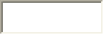
3. Service Tax @ 12.36% (Subject to changes)
Total Space Charges (Total of 1-2-3)

(We are in process of procuring TDS Exemption Certificate. Please contact TAGMA before deducting TDS on DMI 2008 stall charges)
Details of Payment
- Indian Rupees payments
by Demand Draft in favour of Tool and Gauge Manufacturers Association payable at Mumbai or local cheque.
- US$ & Euro payments by SWIFT transfer only
  - US Dollar payments
To Citibank New York Branch, for credit to Citibank, NA, Mumbai Account No.36241797 (Swift Code - CITIUS33)
Beneficiary Name : Tool & Gauge Manufacturers Association
Beneficiary Bank Account No.: 0-021481-114 (Swift Code - CITIINBX)
Purpose : Participation charges for Diemould 2010
  - Euro payments
To Citibank London Branch, for credit to Citibank, NA, Mumbai Account No.5501024 (Swift Code - CITIGB2L)
Beneficiary Name : Tool & Gauge Manufacturers Association
Beneficiary Bank Account No.: 0-021481-114 (Swift Code-CITIINBX)
Purpose : Participation charges for Diemould 2010
Please Note That Confirmation Of Your Booking Is Subject To Receipt Of 50% Advance Payment With Application

Bottom of Form

Advertisement In Directory

Please complete & return this form along with material & payment on or before 9th January 2010

Company Name *

Address: *

Phone No: * Fax No :

E-mail: *

Name of the Signature : Fax No :

Advertising Rates
  Indian Advertisements | Foreign Advertisements
  Four Color | Four Color
    Rs
     | USD |  | Euro

Full A5 Page | 12000 | 350 | 250
Front Inside * | 16000 | 450 | 325
Back Inside * | 16000 | 450 | 325
Back Cover * | 22000 | 600 | 430
Section Separator / Divider * | 14000 | 400 | 275
Double Spread | 23000 | 600 | 430

Subject to availability *
Technical Data & Details
- Size: Print area 12cms x 19.5cms
Bleed Size 14cms x 22cms
- Booking first on first come reserved basis
- Material: Four color positives are only accepted. If artwork is sent, actual processing cost will be charged extra.
- Color printing Sinar Mass Art Paper
- Payment: DD/Cheque payable to TOOL AND GAUGE MANUFACTURERS ASSOCIATION, MUMBAI.

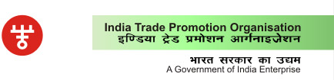

Reference: 144-ITPO (109)/App/2008 Date: 5-8-2008 Phone: 23371830

Tool and Gauge Manufacturers Association
C/o NTTF Industries Ltd.,
23/24 Peenya Industries Area, 11Phase,
Bangalore-560 058

Sub: No objection for holding of DIEMOULD INDIA 2010-International Exhibition,
March 18-21,2010 at Bombay Exhibition Centre, Goregaon, Mumbai.
Ref: Your Application/ letter dated May 22,2008.

Dear Sirs,
India Trade Promotion Organization (ITPO), in exercise of powers conferred on it vide Customs Notification No.3 dated 9.1.1989 as amended by Notification No..66 dated 16.3.1995, approve the holding of the above event subject to the following:

Products covered: Dies & Moulds, Press Tools, Machine Tools for making Dies & Moulds, CNC Milling/Machining Center, E.D.M, Die Casting Machine/Moulding Machine, CAD/CAM system related to Dies & Moulds, Measuring Machine, Rapid Prototyping & Modelling, Digitising, Accessories for Machine Tools, Heat treatment, Cutting Tools, Die/Mould polishing machines, Mould base and standard parts for Dies & Moulds, Die Spotting and Hot runner systems.

Overseas Participation from: Australia, Canada, China, Dekendorf, France, Germany, Hong Kong, Israel, Italy, Japan, Korea, Philippines, Singapore, Slovenia, Spain, Sri Lanka, Sweden, Switzerland, Taiwan, Thailand, The Netherlands, Turkey, U.K.. U.S.A.

NOTE: In case of participation from Taiwan and Pakistan, you are advised to obtain NOC from Co-ordination Division, Ministry of External Affairs, Govt. of India, New Delhi, and Ministry of Home Affairs, Govt. of India, New Delhi.

(b) The approval is issued to your organization and not to any individual person or participant in your exhibition. The facility of duty free temporary import will be available only to foreign exhibitors/participants, who have confirmed their participation in the above exhibition by remitting participation fee in foreign exchange. Temporary import will be allowed under ATA Carnet System and/or against Undertakings, Bond or Bank Guarantee as required by the Customs authorities in India. In this connection, Ministry of Finance (Department of Revenue) Notifications No.157/90-Cus, 14/90-(NT)-Cus, No.158/90-Cus all dated 28-3-90, as amended from time to time and Central Board of Excise and Customs circular No.55-CBEC dated 3-8-1998, etc. refer.

(c) The exhibition will be open to general public or to a particular section of the general public for which it has relevance; and will be in public interest.

(d) The goods will be re-exported within a period of six months from the date import or any other period, as may be stipulated by the Customs Authorities in India.

(e) Parties/exhibitors whose intention is to sell or dispose of exhibits in India should not avail the facility of duty-free import of exhibits facility extended through this letter.

(f) Participation charges from all foreign participants should be collected in foreign currency. Temporary importation may be facilitated only to those exhibitors who pay participation charges in foreign exchange.

(g) The approval is in no way indicative of sponsorship or support of the event by ITPO and any projection of such indication by the organizers by using the name or logo of ITPO would render withdrawal/cancellation of this letter.

(h) ITPO reserves the right to withdraw/cancel the approval at any time without assigning any reason.

(i) A copy of the report of the event with one copy of fair catalogue/exhibitors list should be submitted to ITPO within one month of the conclusion of the event.

Please acknowledge receipt of this letter

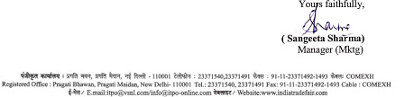

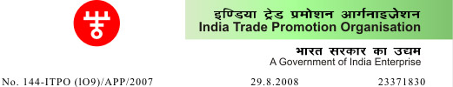
Tool and Gauge Manufacturers Association
C/o NTT FIND. Ltd.
23/24 Peenya Ind. Area
II Phase
Bangalore-560058

Sub :- No objection for inclusion of participation from: Slovakia, Austria, Belgium, Netherlands, Brazil, Bulgaria, Denmark, UAE, Egypt, Hungary, Finland, Gibraltar, Greece, Indonesia, Russia, Kenya, Romania, New Zealand, Portugal, Luxemburg, Mauritius, Morocco, Norway, South Africa, Poland, Belarus, Lebanon, Cyprus, Malaysia, Ireland, Czech Republic in DIEMOULD INDIA 2010 INTERNATIONAL EXHIBITION, March 18 - 21, 2010 at Bombay Exhibition Centre, Goregaon, Mumbai

Dear Sir,
Reference to your letter dated August 20, 2008.This is to inform you that ITPO has no objection to your proposal to include participation from Slovakia, Austria, Belgium, Netherlands, Brazil, Bulgaria, Denmark, UAE, Egypt, Hungary, Finland, Gibraltar, Greece, Indonesia, Russia, Kenya, Romania, New Zealand, Portugal, Luxemburg, Mauritius, Morocco, Norway, South Africa, Poland, Belarus, Lebanon, Cyprus, Malaysia, Ireland, Czech Republic in DIEMOULD INDIA 2010 INTERNATIONAL EXHIBITION, March 18 - 21, 2010 at Bombay Exhibition Centre, Goregaon, Mumbai. Other terms and conditions conditiond in our letter No.144-ITPO{109)/APP/2008 dated 5.8.2008 stand.

Yours faithfully,
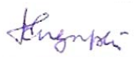
(J. Sengzupta) Manager (Mktg.)

Your Host City - Mumbai


Mumbai, your host city, originally a cluster of seven islands, is today regarded as the "Gateway" to the country. It derives it's name from Mumbadevi, the patron goddess of the koli fisher folk, its oldest inhabitants. A lovely natural harbour and winding creek set off the city of Mumbai from the long, narrow coast of Western India.
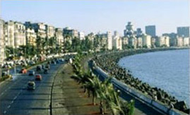
Once a Portuguese princess' dowry and later an adornment of neogothic architechture, the city, which began as a trading post is today, more than just a metropolis. It is the country's financial powerhouse, the nation's industrial heartland and it's economic nerve centre.
The history of this rapid growth of the city, is a tribute to the enterprise and vision of it's citizens.

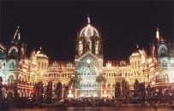
Mumbai pulsates with activity. It is a city that is disciplined by no time frame, neither by day, nor by night. Dazzling shopping arcades, exciting sports activity, high fashions, theatres, music and movies, gourmet restaurants and interesting sightseeing - Mumbai offers the visitor a heady mix of all this and more.



